1. Design a program of Employee in which you have to take information of 05 employees.

Information includes (employee_id, name, date of birth, email, residential address, job title,

salary…etc.) and save all the records in a txt file using StreamWriter.

**SOLUTION:**

Console.Write("Enter no of customers: ");

int n = int.Parse(Console.ReadLine());

string[,] record = new string[n,7];

for (int i = 0; i < n; i++)

{Console.WriteLine("\nenter Detail of Employee {0}!!!\n",i+1);

Console.Write("enter id: ");

record[i,0] = Console.ReadLine();

Console.Write("enter name: ");

record[i,1] = Console.ReadLine();

Console.Write("enter DOB: ");

record[i,2] = Console.ReadLine();

Console.Write("enter SALARY: ");

record[i,3] = Console.ReadLine();

Console.Write("enter Adress: ");

record[i,4] = Console.ReadLine();

Console.Write("enter job_title: ");

record[i,5] = Console.ReadLine();

Console.Write("enter EMAIL: ");

record[i,6] = Console.ReadLine();}

string path = @"myfile1.txt";

using (FileStream file = new FileStream(path, FileMode.Create, FileAccess.Write)){ using (StreamWriter writer = new StreamWriter(file, Encoding.UTF8))

{ writer.WriteLine("\nCus_ID\t\tName\t\tDate of Birth\t\tEMAIL\t\tADRESS\t\tJob-Title\t\tSALARY\n");

for (int i = 0; i < record.GetLength(0); i++) {

for (int j = 0; j < record.GetLength(1); j++) {

writer.Write(record[i,j]+"\t\t"); } writer.WriteLine(); }}

Console.ReadLine(); }

**OUTPUT:**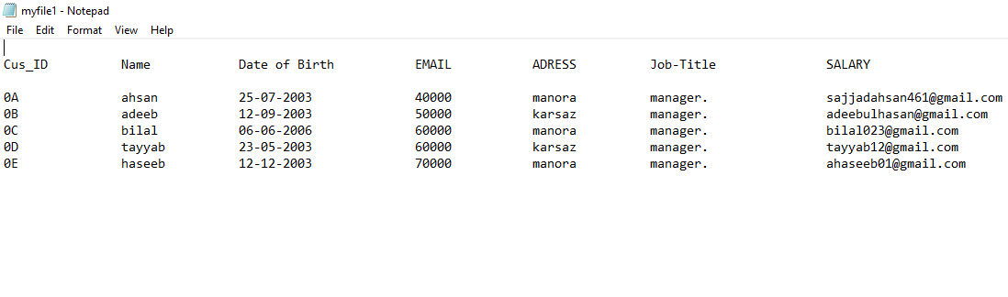

2. Design a program of Grocery items in which you have to take data of 15 items. Items

includes (item_id, item name, date of manufacturing, date of expiration, quantity,

price…etc.). Save all the data in a txt file using StreamWriter and print the data using

StreamReader.

**SOLUTION:** Console.Write("how many items--you want to store data: ");

int n = int.Parse(Console.ReadLine());

string[,] record = new string[n, 6];

for (int i = 0; i < n; i++)

{

Console.WriteLine("\nenter Detail of item {0}!!!\n", i + 1);

Console.Write("enter id: ");

record[i, 0] = Console.ReadLine();

Console.Write("enter name: ");

record[i, 1] = Console.ReadLine();

Console.Write("enter manufacturing date: ");

record[i, 2] = Console.ReadLine();

Console.Write("enter expiration date: ");

record[i, 3] = Console.ReadLine();

Console.Write("enter price: ");

record[i, 4] = Console.ReadLine();

Console.Write("enter Quantity: ");

record[i, 5] = Console.ReadLine();

}

string path = @"mygroceryfile.txt";

using (FileStream file = new FileStream(path, FileMode.Create,FileAccess.Write))

{

using (StreamWriter writer = new StreamWriter(file, Encoding.UTF8))

{writer.WriteLine("\nIt_ID\t\tNAME\t\tMANUFACTURING_D\t\tEXPIRATION_D\t\tPRICE\t\tQUANTITY\n");

for (int i = 0; i < record.GetLength(0); i++)

{

for (int j = 0; j < record.GetLength(1); j++)

{

writer.Write(record[i, j] + "\t\t");

} writer.WriteLine(); } } Console.ReadLine();

**OUTPUT:**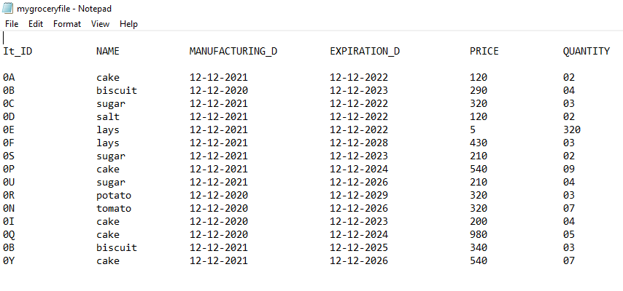

**READ THE FILE USING STREAM READER**

**SOLUTION:** string path = @"mygroceryfile.txt";

using (FileStream file = new FileStream(path, FileMode.Open,FileAccess.Read))

{

using (StreamReader reader = new StreamReader(file, Encoding.UTF8))

{

string record = "";

while ((record=reader.ReadLine())!=null)

{

Console.WriteLine(record);

}

//string record = reader.ReadToEnd();

//Console.WriteLine(record);

}

**OUTPUT:**